Beaver Road Junior School Geography Project

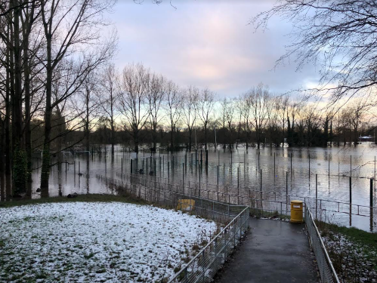
Thank you Years 4, 5 and 6 for taking part in our Geography Research Project, where you will be looking at the risks of flooding in our local area. I’m sure that you will really enjoy it and the research you do will be so valuable when we are thinking about how to reduce future flooding risks.
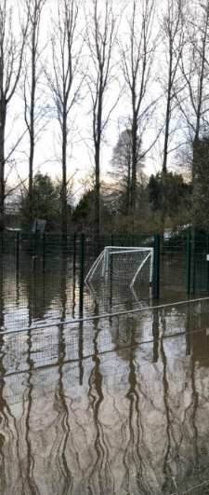
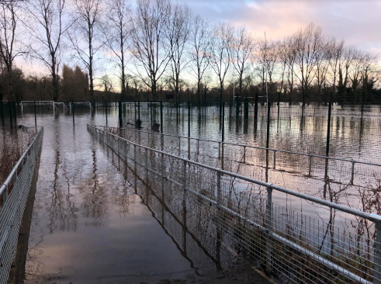

Your teachers will be sharing further information with you, but below are some links that you might find a useful starting point for your research.
Websites to support your research
https://www.bbc.co.uk/news/uk-england-manchester-55746517
https://flood-warning-information.service.gov.uk/target-area/013FWFGM35
https://riverlevels.uk/flood-warning-river-mersey-at-east-didsbury#.YBCCBej7RPY
https://www.researchgate.net/figure/Flood-plain-map-of-the-River-Mersey-between-Northenden-and-Didsbury-showing-the-inlet_fig2_265224458
https://www.getthedata.com/flood-map/east-didsbury

Enjoy your project and we can’t wait to see the work you share on Seesaw.

Mrs Burrows and Mrs Jeacock
Geography Subject Leaders

